A robot waiter

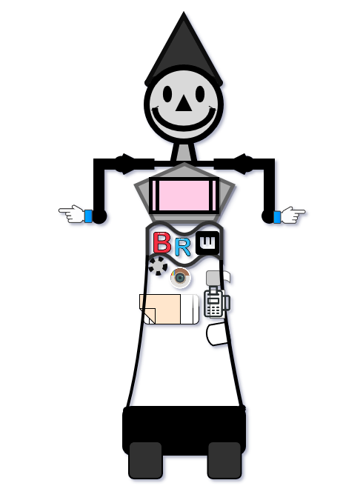

Himel

Abstract

This report details the conceptual design and functionality of a robot waiter intended for use in a restaurant environment. The project aims to improve operational efficiency and customer comfort through automation. The robot's core functions include greeting and seating customers, taking and processing orders via speech recognition or touch pad, handling both card and cash payments, and serving food. The design incorporates accessibility features for people with physical disabilities, and includes a detailed explanation of the robot's hardware and software platform. Key components such as Wi-Fi connectivity, various sensors for navigation, and a specialized "Safe guard" software are outlined. This paper concludes that investing in robotic labor is more efficient than human labor due to the robot's ability to work continuously without error or fatigue.

Introduction

Robots are bound to take the position of human waiter. Nowadays, automation started to serve customers as waiter on behalf of human. Barden (2017) says that, employer Investing in robots is exceptional than human as maintaining robot is cheaper than human. Robot will work in restaurant as they will be instructed by human, they will never make any kind of error as human. Nevertheless, if there is any defect in its instruction it will function wrongly (Barden, 2017). The intent of this report is to progress a robot waiter for a restaurant which can serve customer to make life comfortable. This robot main role is to serve customers. There is a robot waiter diagram below:

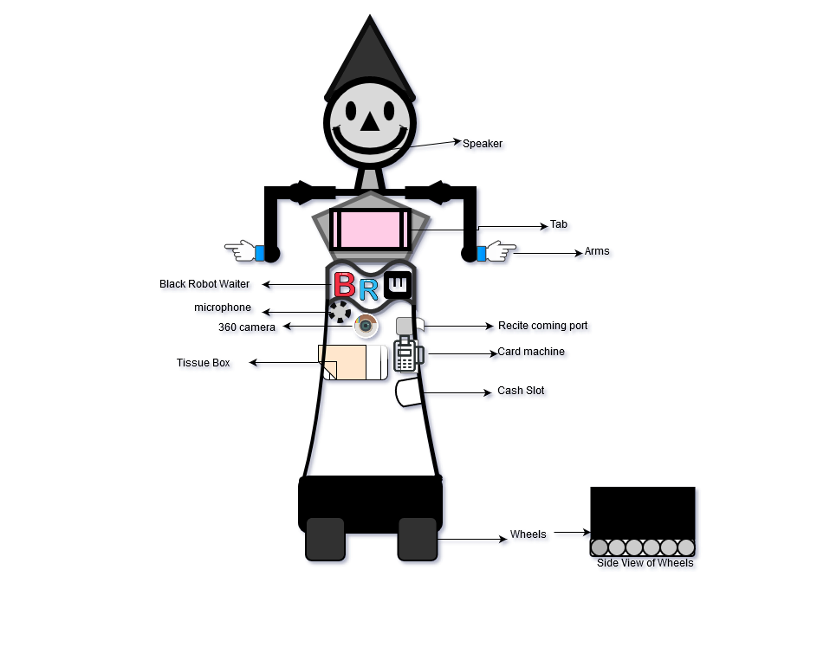
Robots are there to make work more proficient and successful as robots are cheap to employ. It will be able talk with customers as well as serving customers as it will have various process to interact with.

The functionality of a robot waiter:
Language: It is functioned to speak in English. If someone speak different language, it will ask help from staff.

Greeting customers: Robot will be standing all around the restaurant waiting for customers whenever its notice customers, it will move towards customer and will say “Hello” to them.

Seating customers: When Customers ask for seats, instantly robot will search in its system for available table and seats in the restaurant. It will locate the table number and will take customers to that location. Robot will ask customers to take their seats and will give some time to look in menu or they can order immediately if they want to.

Taking customers order: If customers are ready to order robot will take their order, either by talking to them or in touch pad. After taking order robot will save order in its device which can be accessed by kitchen staff and on the same time robot will show the billing option to customers.

Process payment (Card or Cash): If Customer pay by card, robot will show a light in card machine area. Card machine is contactless but only accepted below £30. Receipts will come out after paying. However, if they pay cash, they have to put money in cash slot and robot will go in till and if needed it will get change from staff to return customer.

Bringing food to customers: After taking order robot will line-up in kitchen and will wait until the food is ready. When food will be ready, staff will help robot to take food in a tray and robot will bring the food to customers and will ask them to take their food (if needed staff will help robot to give food in table). After serving food it will say “Enjoy your meal” and will go for other works.

Cleaning the table: Customer will tap the button (fitted in table for calling robot) so it will come and take all dishes back to kitchen (helped by staff or customers). On the same time robot will ask customers to take tissue from its tissue box fitted in right side.

However, if kitchen staff run out of anything, they can use robot’s tab online function to order groceries for their restaurant and accessories as well.

Below are the modular function of this robot:
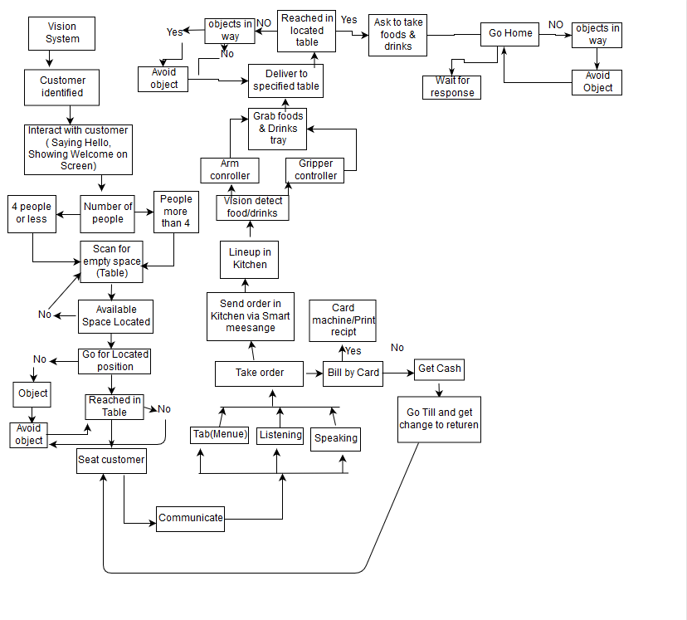
Accessibility features:
Are very useful for disable people. They can order food by talking to robot or they can use tab.

Speech-recognition: This feature can be used by blind, deaf, and Physical disable people. If they are unable to see, listen or move they can call robot and talk to it from their seat.

Touch pad: Can be used by deaf, dumb people. If people cannot speak or listen, robot has got touch tab function so that they can use it.
However, this robot is not accessible by the person who have both blindness and dumbness.
Below is a diagram of robot:
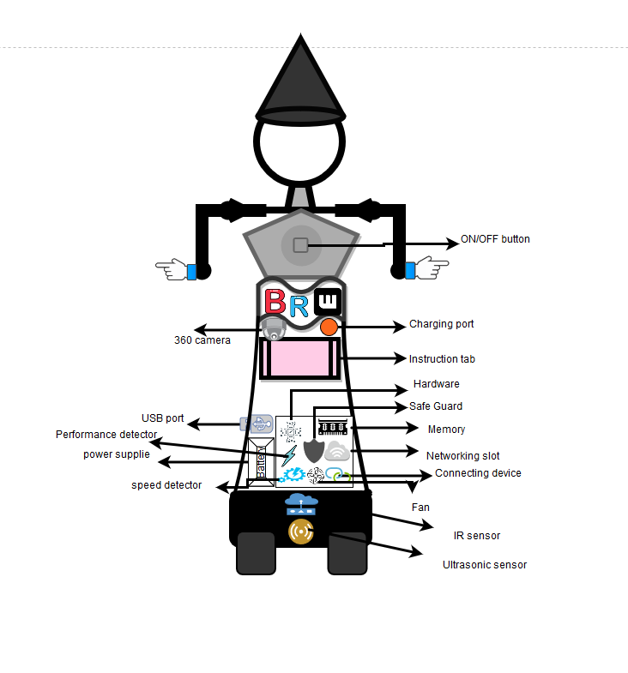
Explanation of Robot platform
Hardware: Is a special part of robot where it is designed to run the system. All software is installed in hardware to do its function. However, without software hardware will not know what to do.

Software: Is stored in memory of the robot where it is loaded in hardware to give instructions to function.
Memory: Is fitted inside to save all different software in it where it can be updated and removed as wanted.

Speaker: With the help of speaker robot can communicate with customers. Speaker is fitted in its mouth so that people will feel like they are talking to a human waiter.

Voice: It is designed to talk like a lady. Special kind of software is installed.

Touch pads: There are two pads, front Touch pad will be fitted in its chest so that it will be easier for customers to see and use it. It can be used to take order and Pop-up bill section after completing order. However, the other one is fitted in its back which is used for instructing robot by restaurant staff.

Microphone: Is fitted right below after touch pad. Customer can order food by talking to robot and to make sure their order is correct, touch pad will show the food names with price on side.

360 cameras: Two cameras are fitted in it, one is on the back and another one is in front. Camera is used in it to see its surrounding and detect things like people, wall etc. However, if anything in its way it can see and interact with the environment around it.

Card machine: Fitted in robot waist.

Power button: Used for switching ON/OFF the robot. When battery run out it will signal and will go to its charging area where staff will switch it OFF and put it in charge. However, they will replace it by turning ON another robot. However, power button is finger sensor so that nobody can use it without staff.

Charging port: An electric cable is connected to this port to charge the robot after it runs out of charge.

Re-chargeable battery: It is a type of lithium battery pack with longer battery life with bigger size so that it can last longer.

USB port: It is used to install any important updates about menu, its instructions, software etc.

Fan: Is needed to cool the interior part of robot.

Safe guard: is a kind of special software used to secure system such as Camera, instruction, and touch pad from harmful things.

Wi-Fi connector: Restaurant Wi-Fi connect automatically after switching the robot ON. Robot connect restaurant system with its system so that staff can see customers order and table number.

Sensor: A complex laser distance detector is fitted to detect the distance of wall, people etc. However, IR sensor is fitted to designate path like pathfinder. Sensor allow robot to identify objects in restaurant as like if it can see any obstacle in its way of driving, it will send this information to hard drive so hard drive will send signal to muscle system based on information so that robot can interact with the object surrounding it.

Wheels: Carbon fiber wheels is used with a rubber belt so that it can move in wet floor. However, Robot is be instructed to move slowly so that food and drinks will not fall down from its tray.

Conclusion
This design will best suits for everyone from children to older people including disable. It will work for longer period, keep on moving in wet floor, serve customers beyond they expect from a robot. Investing in robot is much better than investing in human as it work continuously without getting tired.

Reference:
Barden, J. (2017). The Pros and Cons of Having Robots in the Workplace. [Online] Do Better Hiring - The RecruitLoop Blog. Available at: https://recruitloop.com/blog/the-pros-and-cons-of-having-robots-in-the-workplace/ [Accessed 3 Nov. 2018].

EnduranceRobots. (2018). Description of the Robot-Waiter Wheeled Platform - EnduranceRobots. [online] Available at: http://endurancerobots.com/description-of-the-robot-waiter-wheeled-platform/ [Accessed 8 Nov. 2018].

Sites.google.com. (2018). How Robots Function - Robotics In Our World. [online] Available at: https://sites.google.com/site/roboticsinourworldnow/how-robots-function [Accessed 8 Nov. 2018].

Herts.instructure.com. (2018). Sign In. [online] Available at: https://herts.instructure.com/courses/30226/files/216521?module_item_id=246634 [Accessed 8 Nov. 2018].

